MINI PROJECT- SYNOPSIS ON

Doctor Appointment System



**Submitted By Submitted To**

Aryan Reddy (201500156) Ms. Neelam Soni

Ankit Gupta (201500100) (Technical Trainer) Aryan Gupta (201500151) Training and Development Department Krishna Mittal (201500351)

# INTRODUCTION

In today's fast-paced world, managing appointments and schedules efficiently is crucial for healthcare providers. The Doctor Appointment System project aims to streamline the process of scheduling and managing appointments for doctors and patients, making it more convenient and efficient for all parties involved.

The Doctor Appointment System project is designed to be a web-based application that facilitates appointment booking, scheduling, and management for doctors, patients, and clinic staff. It provides an easy-to-use interface for patients to book appointments online, while also offering doctors and clinic staff a centralized platform to manage their schedules, view and confirm appointments, and communicate with patients.

The key features of the Doctor Appointment System project may include:

1. Online Appointment Booking: Patients can register and book appointments online through the system, eliminating the need for phone calls or in-person visits to book appointments.
2. Doctor Availability Management: Doctors and clinic staff can set their availability and update their schedules, allowing patients to view their availability and book appointments accordingly.
3. Appointment Reminders: The system can send automated appointment reminders to patients via email or SMS, reducing no-shows and improving overall appointment adherence.

In conclusion, the Doctor Appointment System project aims to streamline the appointment booking and management process for doctors, patients, and clinic staff, making it more convenient, efficient, and secure. It can help improve patient satisfaction, reduce no-shows, optimize scheduling processes, and enhance overall clinic operation.

**ABSTRACT**

The doctor appointment project is a software application designed to streamline the process of scheduling and managing appointments between patients and doctors in a clinic or hospital setting. The project aims to provide a convenient and efficient appointment management system that enhances the patient experience, improves doctor productivity, and optimizes clinic operations.

The system allows patients to register and provide their personal information, including medical history, in a secure database. Doctors or healthcare providers can create profiles with information such as their name, specialization, contact details, and availability. Patients can request appointments with doctors based on their availability, and the system checks for available time slots. Appointment notifications are sent to patients via email or SMS to remind them of upcoming appointments.

The system also facilitates the maintenance of electronic medical records, allowing doctors to access and update patient information easily, and generate reports and analytics for data-driven decision-making. Billing and payment features are integrated to streamline the billing process and improve revenue cycle management. The system also ensures compliance with relevant healthcare regulations, such as HIPAA, to protect patient information.

The doctor appointment project aims to improve the efficiency of appointment management, enhance the patient experience, increase doctor productivity, streamline data management, improve billing and payment processes, provide analytics and reporting insights, and ensure compliance with healthcare regulations, ultimately benefiting both patients and doctors in the healthcare setting.

**OBJECTIVE**

The objective of the doctor appointment system project is to develop a software application or platform that facilitates efficient and convenient scheduling and management of appointments between patients and doctors in a clinic or hospital setting. The main objectives of the project can include:

1. Streamlining Appointment Management: The system should provide a user-friendly interface for patients to schedule appointments with doctors based on their availability, reducing manual scheduling and coordination efforts. It should also allow doctors to view, manage, and update their appointments in an organized manner.
2. Enhancing Patient Experience: The system should provide a convenient and seamless appointment scheduling process for patients, allowing them to easily request appointments, receive appointment notifications, and manage their appointments online. This should reduce waiting times, improve patient compliance, and enhance overall patient satisfaction.
3. Improving Doctor Productivity: The system should enable doctors or healthcare providers to efficiently manage their appointments, access patient information, and update electronic medical records. This should reduce administrative overhead, optimize scheduling, and allow doctors to focus on providing quality patient care.
4. Streamlining Data Management: The system should facilitate the maintenance of electronic medical records, allowing doctors to easily access, update, and manage patient information securely. It should also generate reports and analytics for data-driven decision-making, optimizing clinic operations and improving patient care.
5. Improving Billing and Payment Processes: The system should integrate billing and payment features to streamline the billing process, generate invoices, and track payments. This should improve financial management for the clinic or hospital, reduce billing errors, and optimize revenue cycle management.
6. Ensuring Security and Compliance: The system should prioritize data security and comply with relevant healthcare regulations, such as HIPAA, to protect patient information and ensure compliance with legal requirements related to patient data privacy and security.

Overall, the objective of the doctor appointment system project is to develop a comprehensive and efficient software application that enhances the appointment scheduling process, improves patient experience, increases doctor productivity, streamlines data management, optimizes billing and payment processes, and ensures security and compliance in the healthcare setting.

**Top of Form**

**Feasibility Study**

1. Introduction: The doctor appointment system project aims to develop a web-based platform that allows patients to book appointments with doctors online. The feasibility study is an essential step in the project development process to determine the viability and potential success of the project. This feasibility study evaluates the technical, economic, operational, and scheduling aspects of the doctor appointment system project.
2. Technical Feasibility: The technical feasibility of the doctor appointment system project involves assessing the technical capabilities and requirements for implementing the system. Factors to consider include the availability of the necessary technology, infrastructure, and resources to develop and maintain the system. This may include evaluating the programming languages, databases, hosting requirements, and other technical aspects. Based on the expertise and resources available, the technical feasibility of the project is deemed high as the development team has the necessary skills and infrastructure to implement the system.
3. Economic Feasibility: The economic feasibility of the doctor appointment system project involves evaluating the financial viability of the project. This includes estimating the project costs, such as development costs, operational costs, and maintenance costs, and comparing them with the expected benefits and return on investment (ROI). Additionally, the potential revenue streams, such as service fees from doctors or hospitals, can also be considered. Based on market research and financial projections, the economic feasibility of the project is assessed to be positive, with potential revenue streams covering the costs and generating profits.
4. Operational Feasibility: The operational feasibility of the doctor appointment system project involves assessing the practicality and effectiveness of implementing the system in the current operational environment. This includes evaluating the readiness and willingness of doctors, hospitals, and patients to adopt and use the system. Factors such as user acceptance, potential barriers to adoption, and change management

strategies need to be considered. Based on market research and stakeholder feedback, the operational feasibility of the project is considered favorable, with a positive outlook on adoption and usage.

1. Scheduling Feasibility: The scheduling feasibility of the doctor appointment system project involves assessing the time and resources required to complete the project within the defined timeline. This includes evaluating the availability of skilled resources, potential risks and challenges, and project management capabilities. A detailed project plan and timeline need to be developed and reviewed to ensure that the project can be completed on time. Based on the availability of resources and project management capabilities, the scheduling feasibility of the project is assessed to be manageable and achievable.

**System Requirement**

The Software Requirements Specification is produced at the culmination of the analysis task. The function and performance allocated to software as part of system engineering are refined by establishing a complete information description, a detailed functional and behavioral description, an indication of performance requirements and design constraints, appropriate validation criteria, and other data pertinent to requirements.

**The proposed system has the following requirements:**

* System needs store information about new entry of Doctor.
* System needs to help the internal staff to keep information of Appointment and find them as per various queries.
* System need to maintain quantity record.
* System need to keep the record of Patient.
* System need to update and delete the record.
* System also needs a search area.
* It also needs a security system to prevent data

# SOFTWARE SPECIFICATIONS

* + **Language Used :** HTML, JavaScript, MongoDB, ExpressJS, React JS

### User Interface Design : CSS

* + **Web Browser :** Microsoft Edge, Google Chrome and Firefox

# HARDWARE REQUIREMENTS

* + **Processor :** Pentium 4 or above
  + **Operating System :** Windows 7 or above
  + **RAM :** 4GB
  + **Hardware Devices :** Keyboard, Mouse
  + **Hard Disk :** Above 10 GB
  + **Display :** Super VGA

**FUTURE SCOPE**

The future scope of a doctor appointment system project could encompass several areas,

including:

1. Telemedicine and Virtual Care: With the increasing adoption of telemedicine and virtual care, the doctor appointment system could be expanded to include virtual appointment scheduling, video consultations, and remote monitoring of patients' health conditions. This could provide patients with more flexibility in accessing healthcare services and enable doctors to provide remote consultations and follow-ups, improving patient convenience and expanding access to care.
2. Mobile Applications: Developing mobile applications for the doctor appointment system could allow patients to schedule appointments, receive notifications, access their medical records, and communicate with their doctors on their mobile devices. Mobile applications can provide a convenient and accessible way for patients to interact with the system and manage their appointments, enhancing patient engagement and satisfaction.
3. Integration with Electronic Health Records (EHR): Integrating the doctor appointment system with electronic health records (EHR) systems could enable seamless sharing of patient information between the appointment system and EHR, eliminating the need for duplicate data entry and improving data accuracy. This could streamline data management, enhance the continuity of care, and enable doctors to access up-to-date patient information during appointments.
4. Advanced Analytics and Reporting: Implementing advanced analytics and reporting capabilities in the doctor appointment system could provide insights into appointment scheduling patterns, patient flow, and clinic performance. This could help clinics and hospitals optimize their operations, improve resource allocation, and make data-driven decisions to enhance the overall efficiency of the healthcare facility.
5. Patient Feedback and Reviews: Incorporating features for patient feedback and reviews in the doctor appointment system could allow patients to provide feedback on their experience with the appointment process, doctor's services, and overall satisfaction. This could help clinics and hospitals gather valuable feedback, identify areas for improvement, and enhance patient experience and satisfaction.
6. Integration with Payment Gateways and Insurance Providers: Integrating the doctor appointment system with payment gateways and insurance providers could enable online payment processing and insurance verification, simplifying the billing.
7. Enhanced Security and Compliance: As data security and compliance are critical in healthcare, the future scope of the doctor appointment system could include enhanced security measures, such as multi-factor authentication, encryption, and regular security audits, to protect patient information and ensure compliance with healthcare regulations.

**Overall, the future scope of a doctor appointment system project is vast and can be**

**expanded to include various features and technologies that enhance patient**

**experience, optimize clinic operations, and improve healthcare outcomes.**

**Data Flow Diagrams:**

**Level - 0 DFD:**

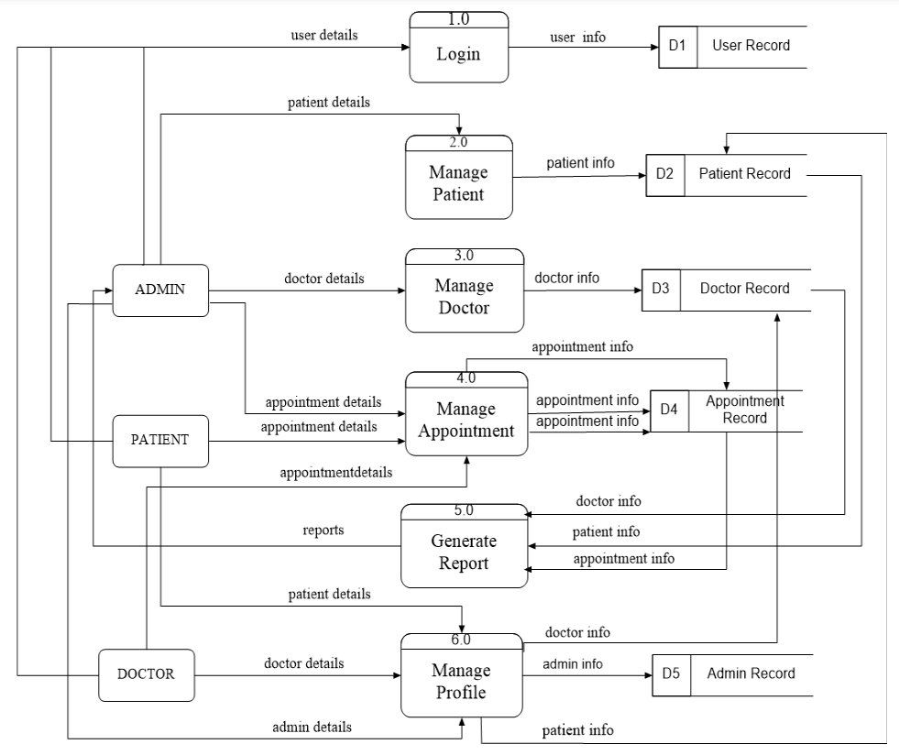

**Level - 1 DFD (Manage Patient):**

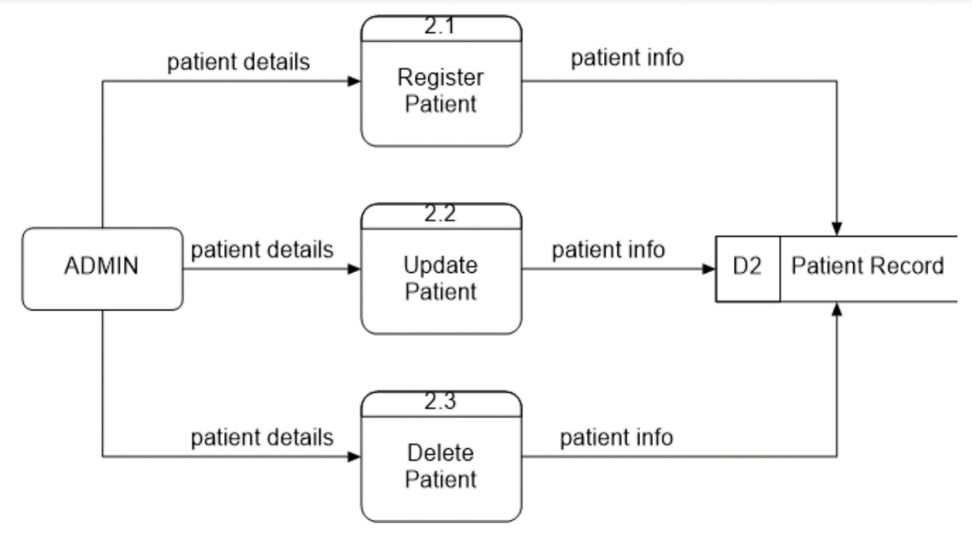

**Level - 1 DFD (Manage Doctor):**

**­**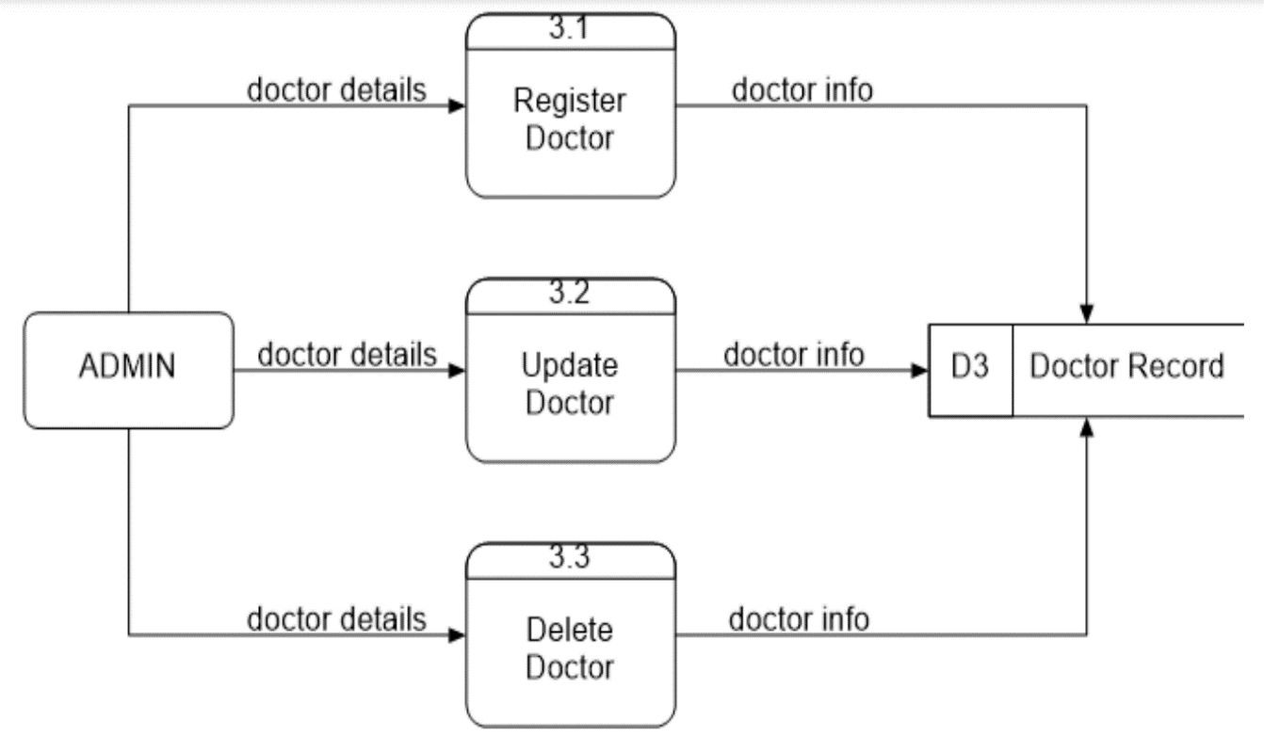

## REFERENCES

### Books:

* Design and Development of an Online Doctor Appointment System.
* Building a Web-Based Appointment System for Medical Services.
* Design and Implementation of a Doctor Appointment System.
* Design and Implementation of a Web-Based Doctor Appointment System.

### Websites:

* + - * <https://www.w3schools.com/>
      * <https://getbootstrap.com/>
      * [www.google.com](http://www.google.com/)

## Faculty Guidelines:

Ms. Neelam Soni (Technical Trainer, GLA University)

**GitHub Repository link:**

[**https://github.com/aryanreddy981/DocApp-Mini_Project**](https://github.com/aryanreddy981/DocApp-Mini_Project)